EXPERIMENT 11 ONLINE SUPER MARKET

Step 1: Creating an application as ’online super market’

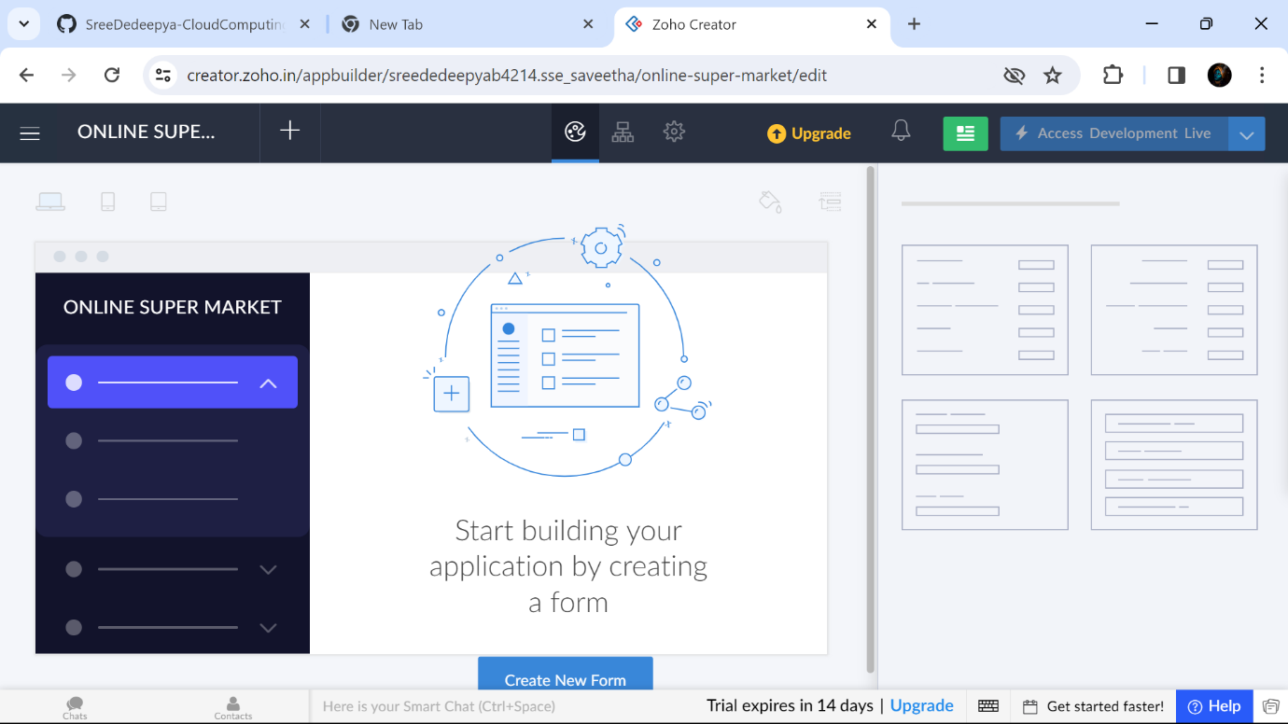

Step 2:Creating a form for the customer Details

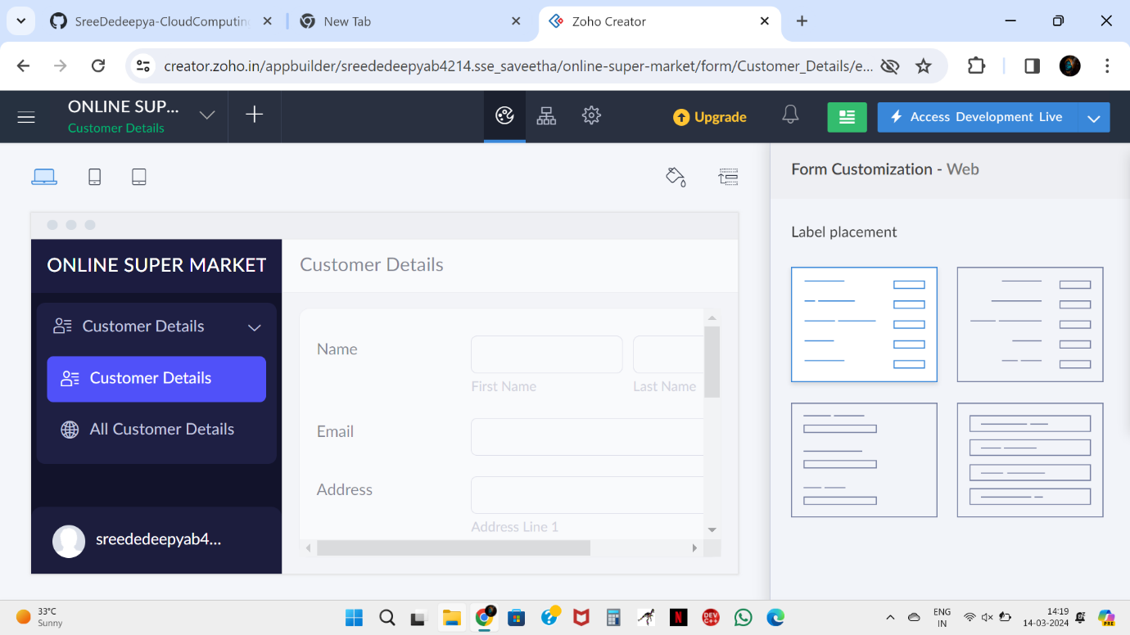

Step 3:Creating a form for the Item Details

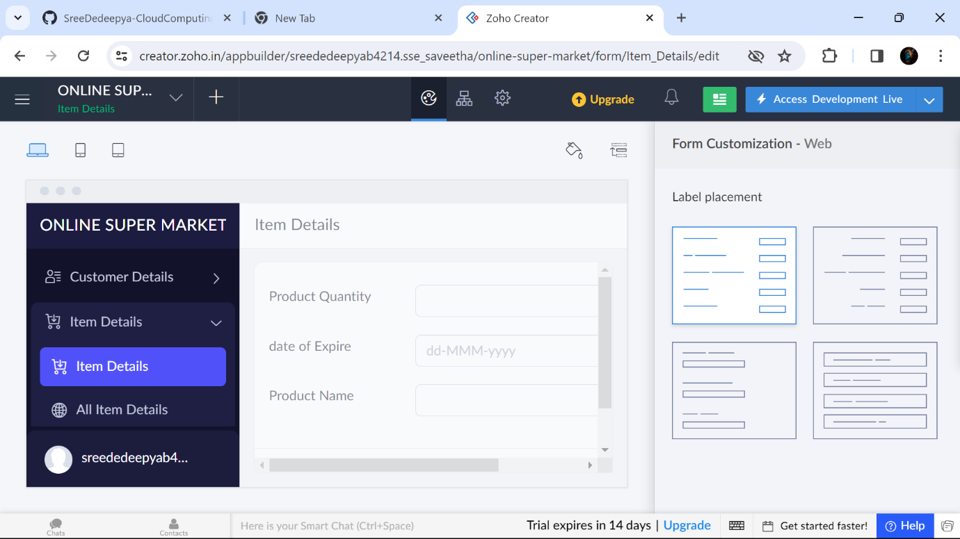

Step 4:Creating a form for the Payment Details

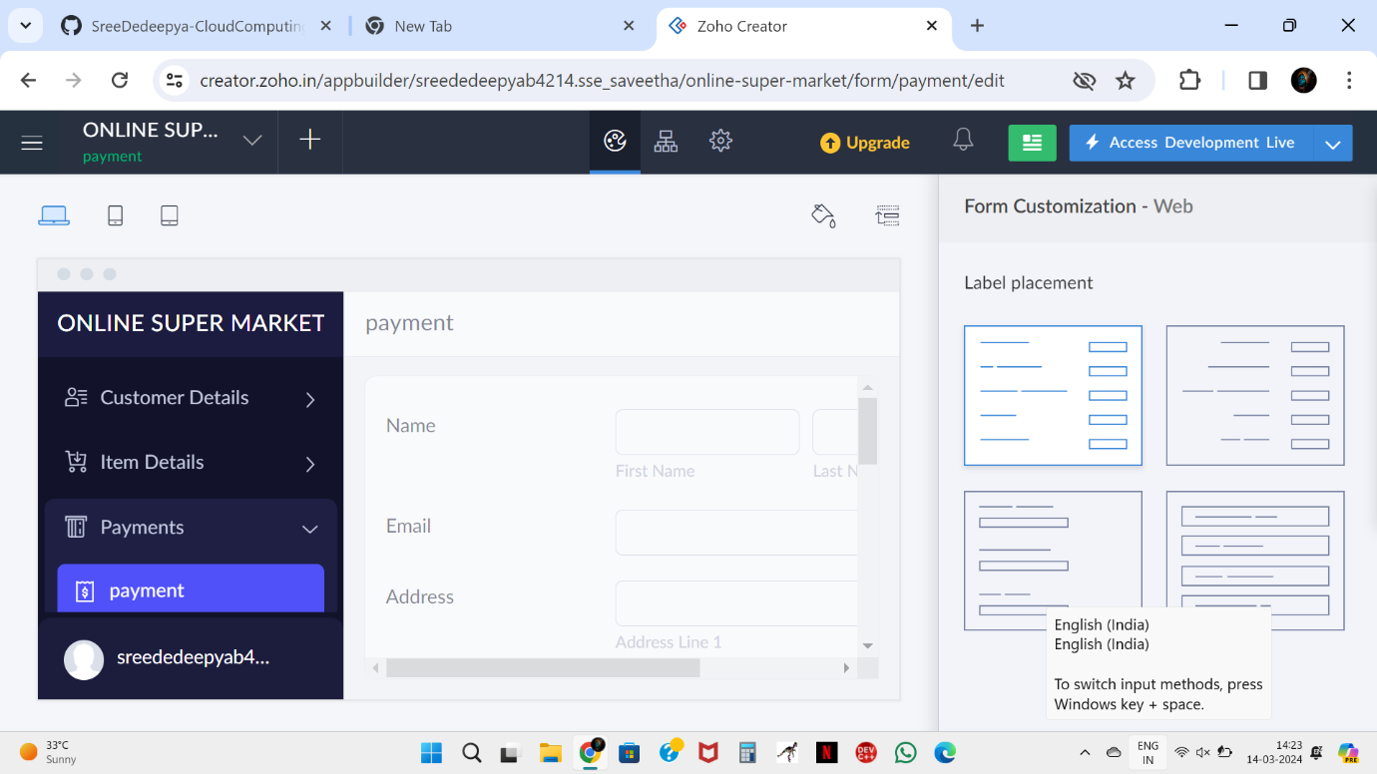

Step 5:Displaying the information of Customer details

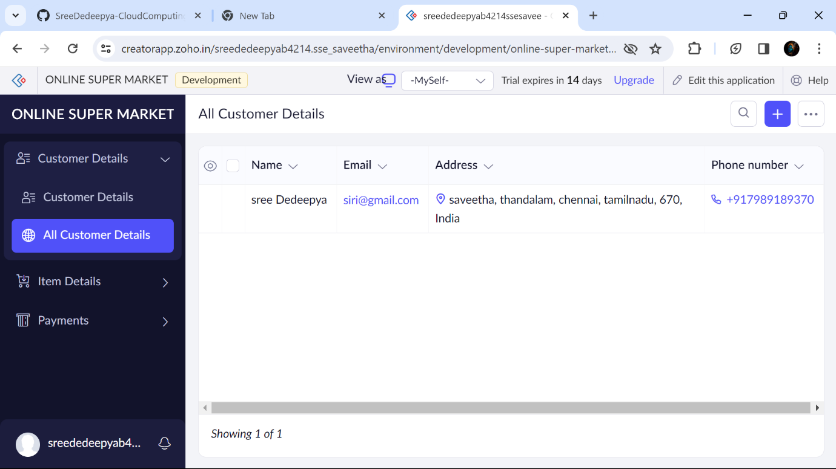

Step 6:Displaying the information of Item details

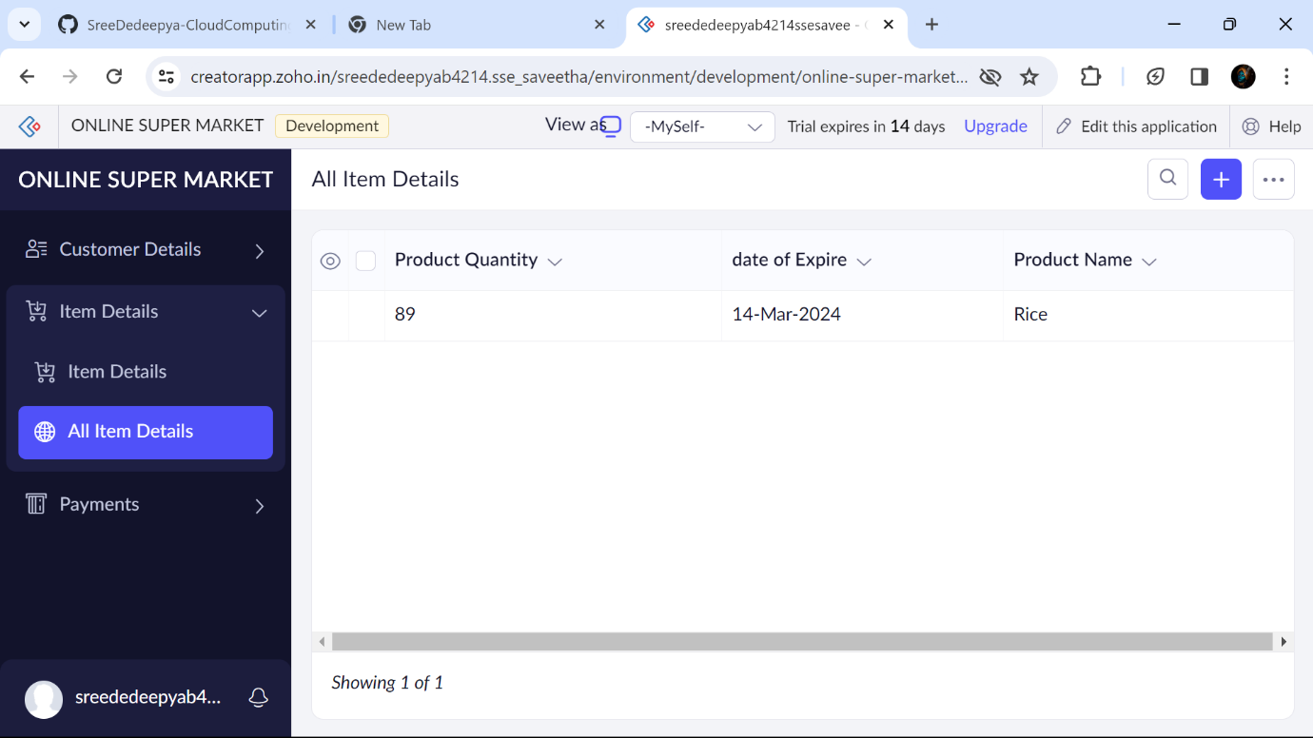

Step 7:Displaying the information of All Paymentdetails

